PROJECT-PRERNA-IND/76278
NAME OF THE ORGANIZATION: JEEVANDHARA SAMAJ KALYAN SANSTHA
Title of the Project: PRERNA, (Inspiration) Empowering Victimized Women for Economic Self-reliance and Dignified Social Life
Project Ref No: IND/76278
Project Location: 10 villages of Jaipur district of Rajasthan
Position : NON GOVERNMENTAL ORGANIZATION
E- mail: jsksjaipur@gmail.com
Mobile: 7010448291

(Inspiration) Empowering Victimized Women for Economic Self-reliance and Dignified Social Life.
Starting date: 1st September 2024
Completion date: 31st January 2025
Address of the project Holder: The Director, Jevvandhara Samaj Kalyan Sanstha, St. Mary’s Convent School Compound, Lalsot Road, Dausa, Rajasthan, 303303
Legal holder: President, Jeevandhara Samaj Kalyan Sanstha, Bishop’s House, Ghat Gate, Jaipur, Rajasthan, 302004

Thematic Area: Sustainable Livelihood promotion
Project area : 10 villages of Jaipur district of Rajasthan
Number of target Groups: 300 Victimized women

EMPOWERING VITIMIZED WOMEN FOR ECONOMIC SELF-RELIANCE AND DIGNIFIED SOCIAL LIFE.
EXTENSION REPORT OF FIVE MONTHS (1st September 2024 to 31st January 2025)
We are pleased to present a narrative report of the five- months extension project, “Prerna” IND/76278.This project has demonstrated significant progress in empowering victimized women through skill development and economic empowerment initiatives. Over the past five months, Project Prerna has brought about tremendous changes in the lives of women and girls through various skill training programs, such as Bag stitching, Cot making, Papad making, pickle & surf making tailoring and other awareness programs.
While challenges remain, the project has provided a crucial platform for these women rebuild their lives and regain their dignity. Continued support and collaboration are essential to ensure the long term success of these effort and created a more equitable and inclusive society for all.
DISCRIPTION OF KEY ACTIVITIES
1. TRAINING ON PICKLE, SURF, AND PHENYL IN TWO VILLAGES:
A four-day training session on traditional and value-added food processing, focusing on pickle, surf, and phenyl making, was conducted in Ghati and Raipur villages. This initiative aimed to empower local women by equipping them with valuable skills to improve household incomes through home-based businesses. 68 women and girls from the project area participated, learning to make various pickles, including mixed pickle, gooseberry pickle (abundant in Rajasthan during winter), and lemon pickle. They also learned to produce different types of floor cleaners and disinfectants. This training has the potential to create self-employment opportunities for these women."
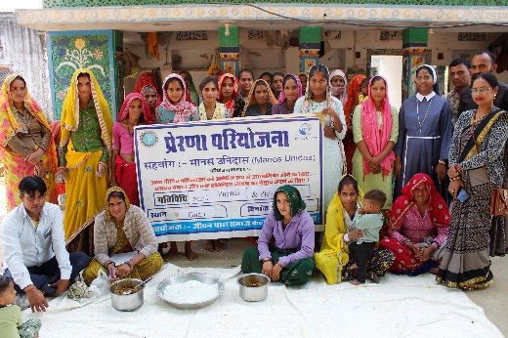
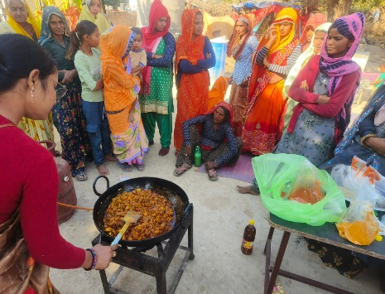
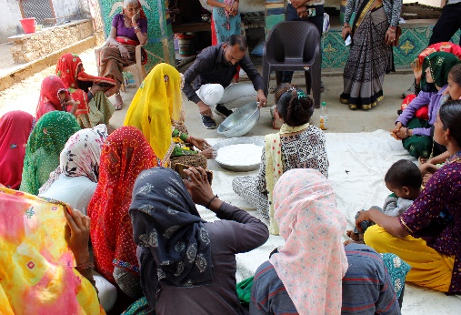
Result: This training had several positive outcomes for the women and girls, including increased income, improved skill development and confidence, and specially provided them with knowledge about starting home business.68 women participated, and 55 of them successfully completed the training on making pickles, surf, and phenyl.30 women have started small –scale production of pickles, surf, and phenyl for home based business.

2. SKILL TRAINING ON BAG MAKING IN TWO VILLAGES:
A ten days training on bag stitching was conducted in the villages of Bassi & Dantli. The program began with prayer and an inauguration. The purpose of the training was to empower women and make them self-sufficient. Fr. Lakwin, the director of Jeevandhara also encouraged the women about the need of learning different skill training and become self-sufficient. Coming together also helped the women to share their experiences and support each other. Women actively learned to stitch different types of bags. The trainer took great care to teach the women. The Project coordinator Sr. Benitta, motivated the women to strive for perfection in their learning.72 women and girls participated in the trainings.
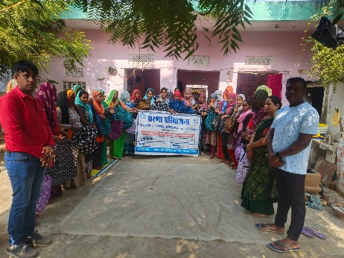
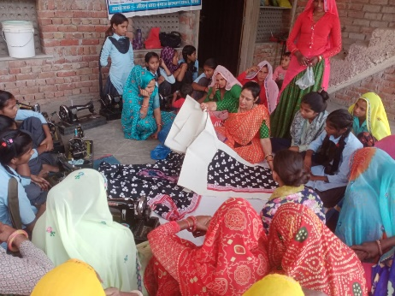
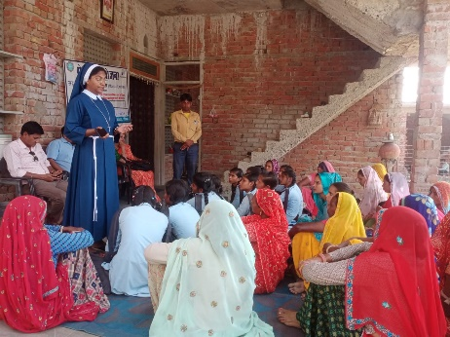
Result: Women learned to stitch various types of bags, a valuable skill for both personal use and potential income generation.72 women and girls participated in the trainings, and 65 of them successfully learned to stitch different bags. Out of the 65participants 8 have already begun stitching and selling their bags, while the rest are in the process of developing their skills and starting their own ventures. The training also boosted the self-confidence and courage to the women.
3. SKILL TRAINING ON PAPAD MAKING IN 3 VILLAGES:
A twelve – day’s papad making training was conducted in Bassi, Bhagwanpura & Pawata. The aim of the training was to help women generate income through skill training activities. The program began with a prayer and an introduction to the activity. The resource person, Mrs. Rejani Sharma, emphasized the importance learning to make pappad, highlighting its usefulness for the household consumption, marriage and other celebrations. Since many women are engaged in household work and lack independent income, this training will provide them with valuable skill to generate income for their families.115 women and girls participated in the training.
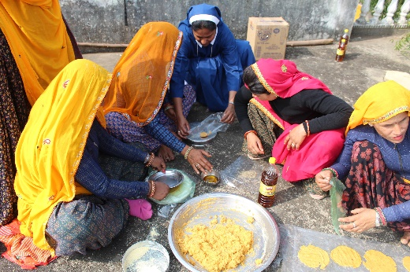
Result: Training on papad making was very useful for the women, 115 women and girls participated in the training .A100 women learned to make different types of papad.55 of them started to make papad for their household use.
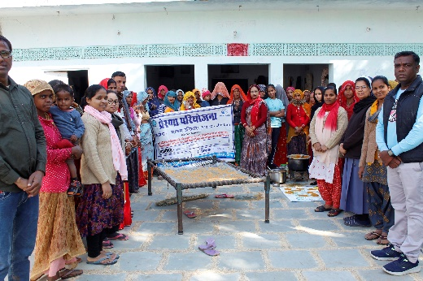
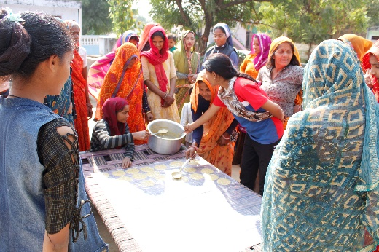
4. SKILL TRAINING ON COT MAKING IN 3 VILLAGES:
Three cot making trainings were conducted in Bhagwaanpura, Dantli & Ghoret villages. The aim was to equip women with skills to make cots, beneficial for their families and as potential income-generating activity. Women actively participated in the training, where the resource person demonstrated various areas also expressed interest in learning. A total of 108 women participated in the training and acquired cot-making skills.
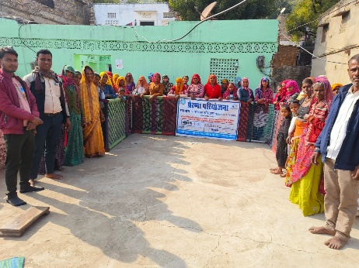
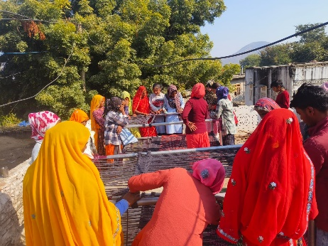
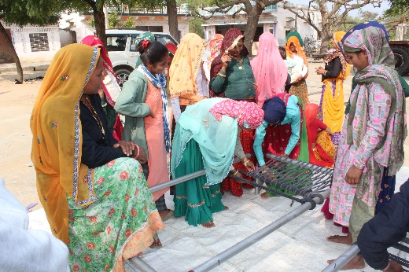
RESULT: Cot making enriched the women. 108 women participated in the training, and 90 of them learned to make. Five have already started to make cots”.

5. SKILL TRAINING ON TAILORING IN TWO VILLAGES:
Two tailoring centres were opened in Dagota & Bassi villages. The program began with a prayer and an introduction. The purpose of the centres was to empower women and girls to learn tailoring skills and become self-sufficient. The prerna team motivated the women to take an interest in learning stitching, which would help them to earn the income for their family. The director of Jeevandhara encouraged the women through his inspiring words, he emphasized the importance of having skills, and using them effectively. Women actively participated in the program and learned to stitch various types of clothes.
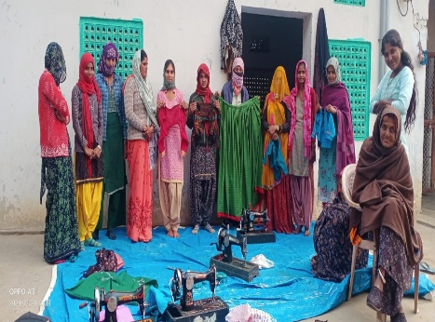
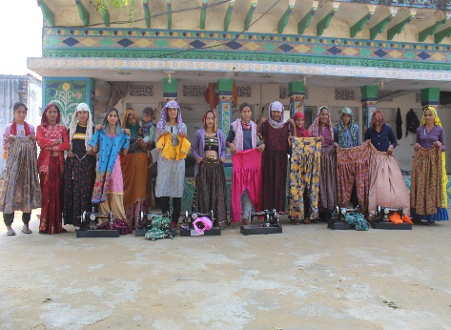
RESULT:74 women and girls learned tailoring ,70 of them learned stitching, and machine operation,15 of them started do stitch clothes, and began earning income.3 of them got the chance to work with exporting company, and they are now engaged in export work.
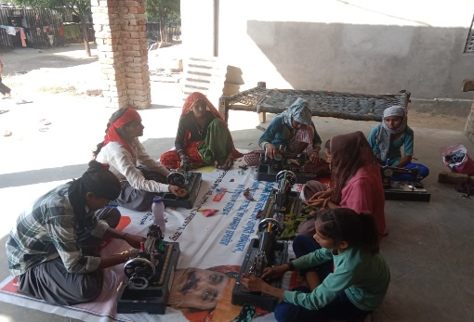
6. TRAINING ON GOVERNMENT SCHEMES & RIGHTS:
10 trainings on government schemes and rights were conducted in the project area. The primary goal was to equip women with knowledge about their rights and available government programs, motivating them to utilize these resources. Resource person led the trainings, providing detailed information on various government schemes. These included Beti Bachao Beti Padhao (Save Daughter & Educate Daughter), widow pension, and other opportunities. The resource person explained the objectives and eligibility criteria for each scheme:
- Beti Bachao Beti Padhao: This scheme aims to address issues such as declining child sex ratio, women's empowerment, gender inequality, and the protection of girl children. It focuses on ensuring girls' education and participation in society, as well as providing them with better educational opportunities.
Widow Pension: This scheme provides monthly pension of Rs. 1,000 for women aged 40-75 and Rs. 1,500 for women over 75. 430 Women actively participated in the program and gained valuable information.
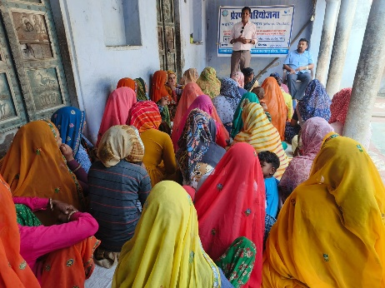
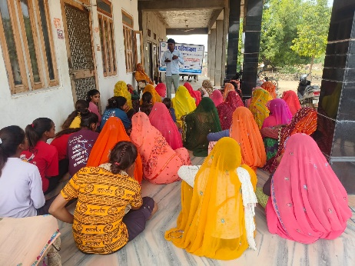
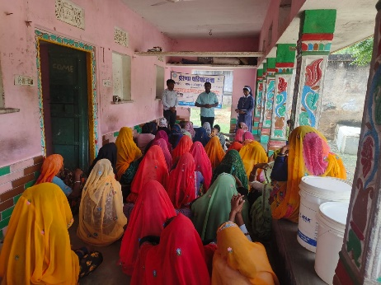
RESULT: Through these trainings, women gained a comprehensive understanding of different schemes and their rights. This increased their self-confidence and knowledge, enabling them to better advocate for themselves and their communities. Women learned to utilize their rights and schemes for the upliftment of their family and community. 430 women attended the trainings. And some of them started to use Government schemes to meet their need.

7. SELF HELP GROUPS REVIEW MEETINGS:
Review meetings of Self Help Groups (SHGs) were conducted in all villages within the project area. The purpose of the review meetings was to assess the functioning of the SHGs, and educate women on maintaining accurate SHG reports and accounts. The Prerna team and other resource persons trained the women on maintaining SHG records and accounts, including how to open accounts for their SHGs. SHG leaders and some members participated in the trainings and learned about SHG records and their essential functions. 304 women participated in the training.
RESULT: The Prerna team has formed 38 SHGs. 420 women became member of 38 SHGs, and started savings. These savings brought sunshine and hope into the lives of women, especially those facing financial struggle in their families. They utilized these savings for children’s education, healthcare, and small business ventures among other needs. They were also motivated, encouraged and uplifted by various awareness programs and skill trainings, which provided them with opportunities to live a better and dignified life in the society.
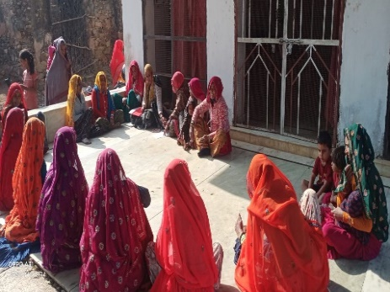
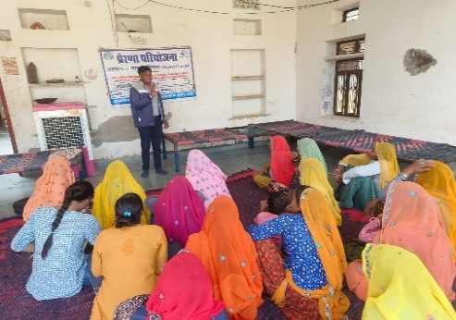
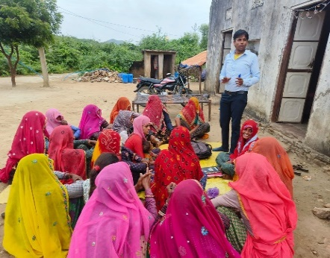
8. STAFF MEETINGS:
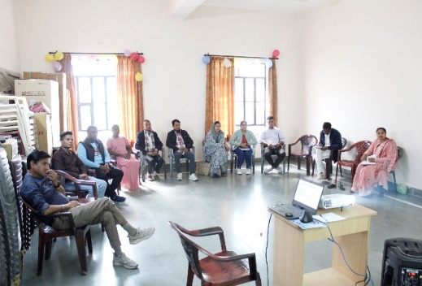
The Prerna staff holds a monthly meeting on the last day of each month to report on and evaluate the activities completed during that month. The staff meeting has been instrumental in ensuring effective communication, coordination, and implementation of Project Prerna activities. The meetings have provided a valuable platform for staff to collaborate, problem-solve, and contribute to the project’s success."
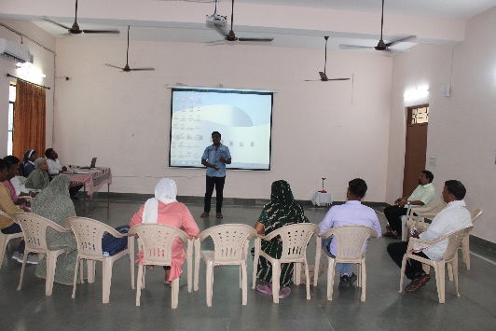
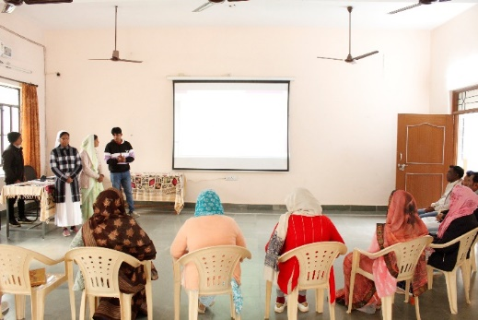
SUCCESSE STORY-1
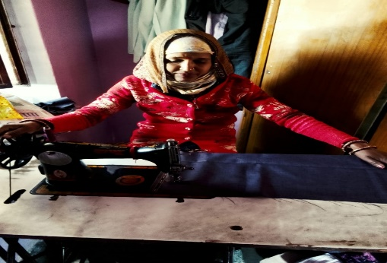
My name is Mamta Devi, wife of Mukesh Prajapat, from Bhawani village. I have 2 daughters and 1 son. I come from a poor family, and I had no money to take care of my family or my children's education. I had lost hope. While I was struggling, I got an opportunity to learn bag stitching through the Prerna project. I learned to stitch different types of bags, and now I stitch and sell them, earning ₹2,000 per month. This income has helped me to support my children's education. I am truly grateful to JSKS and the Manos team for giving me a second chance at life.

SUCCESS STORY-2
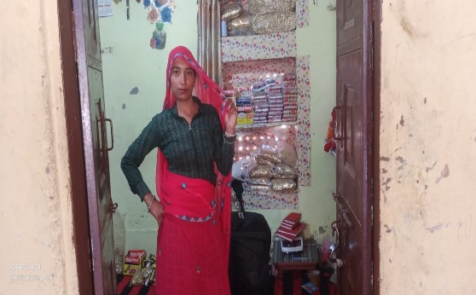
My name is Pinki Devi, and I am the wife of Mukesh Kumar. We live in Bhagwanpura village. For the past two years, I have been involved with Project Prerna and I am also a member of a Self-Help Group (SHG). Our group saves ₹100 per month per member. Each month, the member with the most pressing need takes the accumulated savings as a loan, with a simple interest rate of ₹1 rupee. This helps them to meet their family's needs. I also took a loan of ₹20,000 from my SHG and used it to open a small general store. This store has become a vital source of income for my family. I earn approximately ₹200 per day, which translates to a monthly saving of about ₹6,000. This income allows me to contribute significantly to my family's well-being. I am deeply grateful to the Project Prerna team and the donors for giving me the opportunity to live a more dignified life.

SUCCESS STORY-3
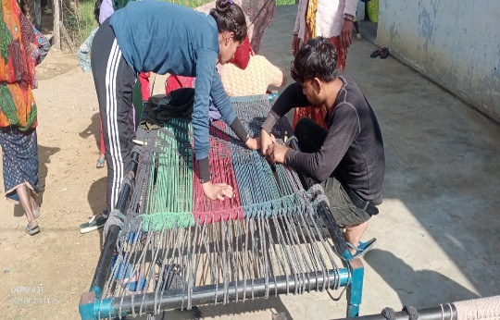
My name is Hasa Gujur daughter of Sharvan Chal Gujur. We live in a Ghati village. For the past two years, I have been a member of the Sanjay Self-Help Group (SHG) under project Prerna. My father works as a daily labour, and we faced significant financial difficulties. I had no opportunities for higher education or skill training outside my village. Traditional customs in Rajasthan often restrict girls from leaving their village for education or training in cities. Like me, many young married women and girls in my community have lost hope and been denied their right to education and other opportunities.
Project Prerna has brought a ray of hope to the lives of many women and girls through various skill training programs and awareness campaigns. I had a chance to learn cot making, a skill training program offered in our village. I joined the training, learned to make cots, and now I make cots for my own home and also sell them. I earn ₹1200 per cot. I am very happy to have acquired this skill and that I am able to support my family. I express my gratitude to Manos unidas and JSKS for giving the great hope for our life.
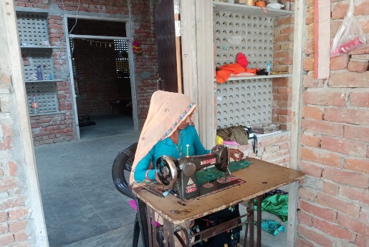
SUCCESS STORY-4
My name is Anchu Yogi, wife of Kalu Ram Yogi. I live in Bassi village. For the past two years, I have been a member of the Prerna Project. My husband is unemployed, and I come from a very poor family with a very weak financial background. I was struggling financially. Through the Prerna Project, I had the opportunity to learn tailoring. I learned to stitch different kinds of clothes and have now started stitching clothes for people, earning ₹200 per day. With this income, I am able to take on the responsibilities of my family. I thank JSKS and Manos Unidas for their timely support, and I hope their generosity will continue to bring positive change to the lives of many village women and girls.
SUCCESS STORY-5
A group of women from Hariarampura village joined the Prerna Project. Before joining, we were like many other women in the village, working from morning till evening in the kitchen, the fields, and tending to our animals. We had no skills training and no knowledge of government schemes or our rights. We became members of the Devnarayan Self-Help Group (SHG). Through the project, we received various skills trainings, including how to make and package incense sticks. Our SHG then secured an export order for incense stick packing, which we are now fulfilling. We earn ₹5 per packet and pack 15 to 20 packets a day. We are truly grateful to JSKS and Manos Unidas for their kindness.
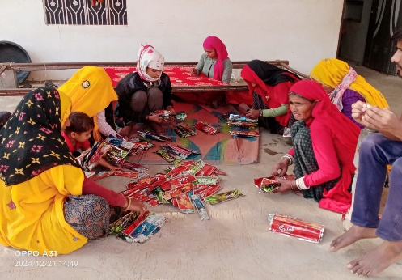
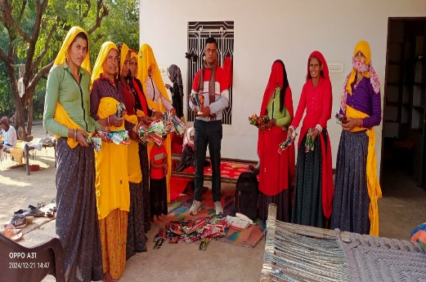

SUCCESS STORY-6
I am Seema Mahawar, daughter of Krishna Lal Mahawar. We are three girls and two boys. My family is very poor, and we struggled financially. During this difficult time, I had the opportunity to learn to stitch bags through the Prerna Project, run by JSKS. I learned to stitch various types of bags. Now I stitch bags independently and contribute to my family's income, earning between ₹1000 and ₹1500 per month. This income helps support my family.
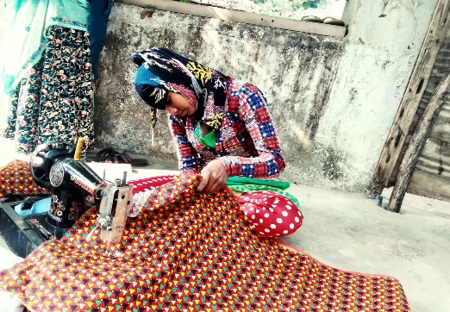
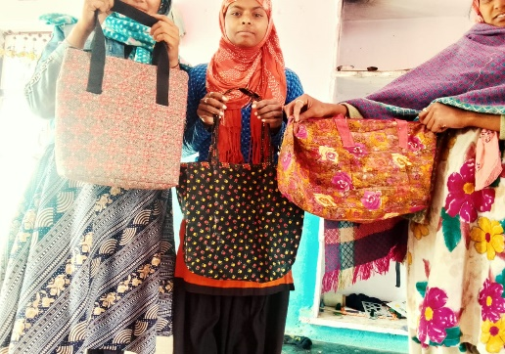

SHG MEETINGS
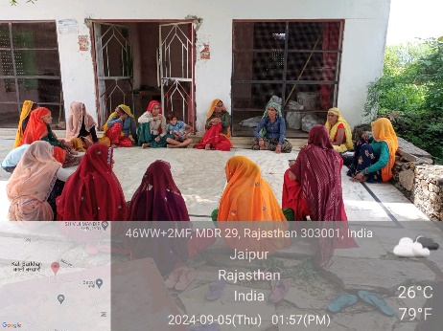
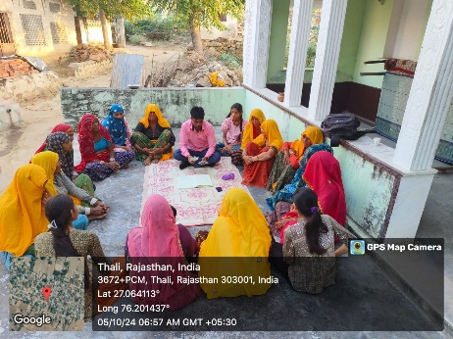
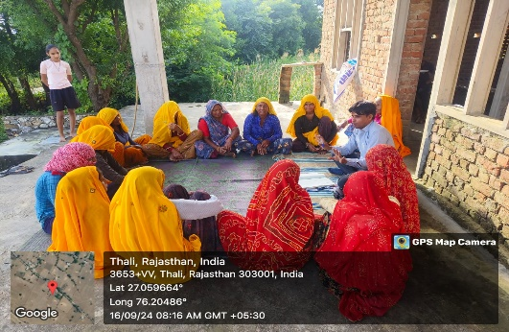
We have 38 Self-Help Groups (SHGs) with 420 women members participating in our Project Prerna. These women have been empowered through various skill training and awareness programs, becoming a source of inspiration for many others in the Jaipur district. Their savings have reduced their financial struggles and increased their income. They express their love and gratitude to the JSKS team and Monos Unidas for their support."
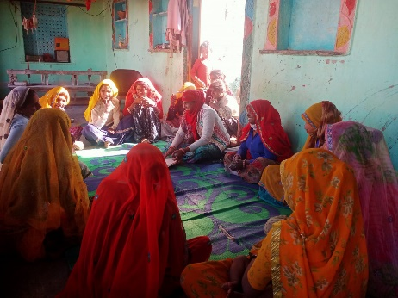
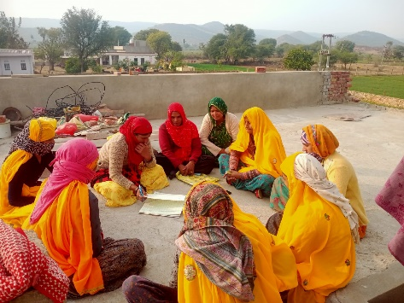
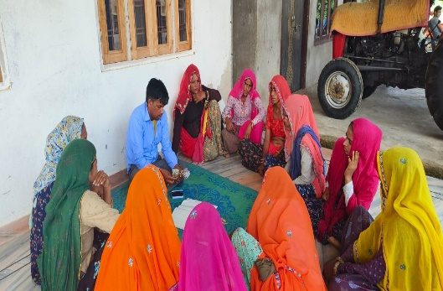
IMPACT OF THE RPJECT
Project Prerna, implemented in 2022, has significantly changed the lives of many women and girls. Over the past two years and five months, 420 women have become members. Various skill training and awareness programs have played a crucial role in these women's lives. The project has transformed their situations, bringing hope where there was none. Women who have acquired new skills are using them to live more dignified lives within their families and communities. Those who previously had no voice are now inspiring other women facing hardship. Overall, Project Prerna has brought remarkable changes, increasing women's confidence, self-esteem, and economic and social standing, contributing to their overall upliftment.
“A TOKEN OF LOVE FOR MANOS UNIDAS”
With the successful completion of Project Prerna-IND/76278, Jeevandhara Samaj Kalyan Sanstha, the project team, the women and girls involved, and other members of the project area express our gratitude to Manos Unidas for the generous support we received for the upliftment of the people of Rajasthan in Jaipur district. The women especially thank Manos Unidas for providing them with opportunities to make a difference in their lives and for helping them to live with dignity. The Jeevandhara team expresses particular thanks to Manos Unidas for their invaluable support and partnership.
Once again, the director of Jeevandhara and the project team express our sincere thanks and indebtedness to Manos Unidas for their timely support and generosity, which enabled Jeevandhara to bring positive change to the lives of many. This expression of gratitude serves as a small token of our deep appreciation and love for your partnership.
"May the Good Lord bless the Manos Unidas team for their kindness and generosity in helping the women of Rajasthan in the Diocese of Jaipur."

Sr. Benitta FSLG
Project Coordinator

